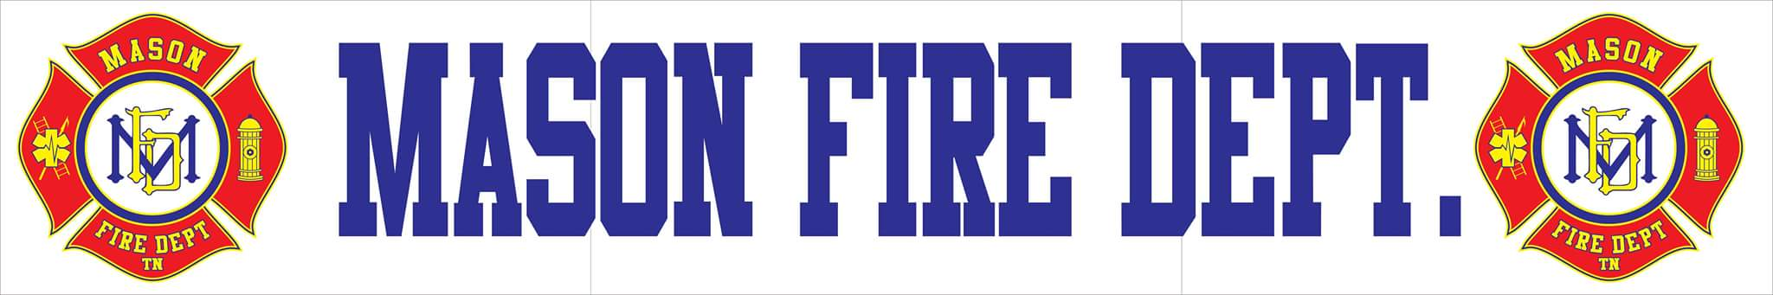
DECEMBER 2020 COMMITTEE REPORT
- For the month of November, Mason Fire Department responded to a total of 13 incidents with a 100% response rate. Those incidents include:
    - 1 Structure Fire
    - 1 Structure Fire (Fayette County)
    - 2 Automatic Fire Alarms
    - 9 EMS Calls

- The ladder truck has been received and is in excellent condition. Equipment and training will be needed prior to putting Truck 73 in service. All are encouraged to visit for a tour.

- The rescue truck has been listed and is advertised on several sources. It is recommended that if a buyer has not been found by February 1st, 2021 that the listing price be reduced from $40,000 to $30,000.

- Burn permits are still not being issued due to fire conditions and will follow suit with the State of Tennessee Division of Forestry to prevent vegetation fires.

- The department has seen some recent turnover in available fire personnel and will begin actively recruiting following January 1st, 2021. There is now a total of three students challenging the Tennessee Fire Commission Firefighter I & II certifications. All are showing great academic progress.

- A meeting was held with Rogers Hydrant Service out of Atwood, Tennessee to discuss the revamping of the Town’s hydrant service to satisfy AWWA, NFPA, and ISO obligations. A newspaper ad will be placed to seek additional quotes from similar competitors. Hydrant service makes up for 40% of the Fire Department’s scoring for ISO. Current pricing is $65.66 per hydrant for three years and $75.00 per hydrant for painting once flow is identified. The town will only be charged per each hydrant found and serviced within a specific geographic area. Services include flushing, testing, GPS tracking, oiling, new ISO specific maintenance logs, and other services saving on manpower hours for the Town.

- Three quotes have been obtained from Municipal Emergency Services, Emergency Vehicle Services, and Safe Industries for the planned replacement of some of our current turnout gear. The department is seeking to replace a total of 9 sets of structural turnout gear (pants and jackets). After January 1st, 2021 there will be a price increase of up to 5% for all vendors. The immediate replacement of the structural gear is most vital, but will only be a start in the overall replacement of available PPE for firefighters.

    - MES (Fire Dex) $13,900.00 Unit Price: $1,544.44
    - Safe Industries (Globe) $18,270.00 Unit Price: $2,030.00
    - EVS (Fire Dex) $17,247.42 Unit Price: $1,916.38

