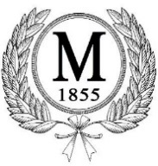

I solemnly swear (or affirm) that I will support the Constitution and will obey the laws of the United States and the State of Tennessee, that I will, in all respects, observe the provisions of the Charter and ordinances of the Town of Mason, and that I will faithfully discharge the duties of the office of “Alderman.”

___________________________
Alderman Shate’ Toliver

___________________________
Mayor Emmit Gooden

___________________________
Town Recorder Lureatha Harris

Emmit D. Gooden, Mayor
egooden@townofmasontn.org

