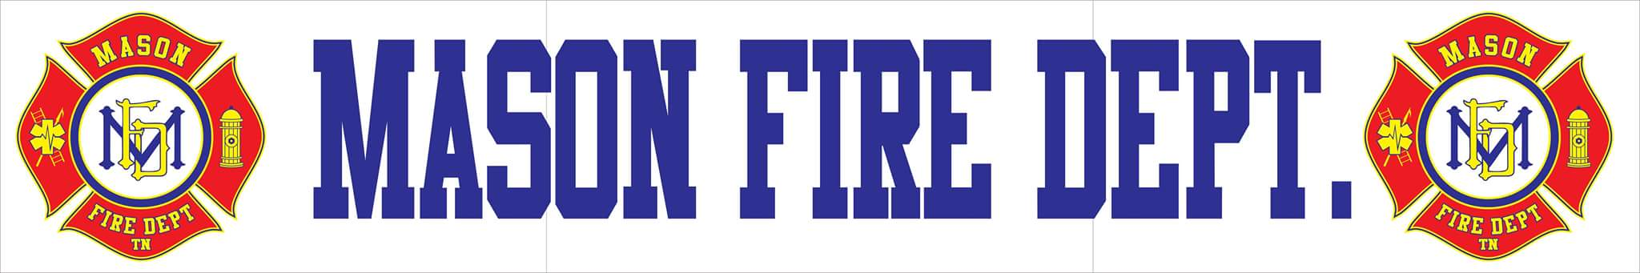
AUGUST 2020 COMMITTEE REPORT
- For the month of July, Mason Fire Department responded to a total of 21 incidents with a 100% response rate. Those incidents include:
    - 14 EMS Calls
    - 2 Fire Incidents
    - 3 EMS Calls (Tipton County)

- Mason Fire Department received a grant from Southwest Tennessee Electric Cooperative for a total of 4 new AEDs and 3 new suction devices totaling $5,930. Keeling Baptist Church also has donated a new air conditioner totaling $1,100.

- This month, Tipton County was selected to be awarded a Regional Assistance to Firefighters Grant from FEMA for county-wide training materials, classes, and equipment for a total of $94,850. All eleven departments in the county will be benefit from these resources with a total match requirement of $862.27 from each department. Some of the equipment are digital fire simulators, class textbooks for multiple class doctrines, state fire courses, and more.

- Engine 72 has been returned from maintenance and is now in full service.

- The department is still in need of new turnouts and has received three quotes from local vendors.

