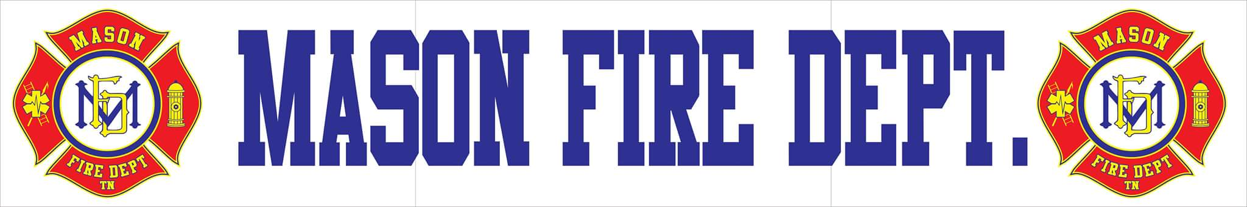
MAFD APRIL 2020 COMMITTEE REPORT
- For the month of March, Mason Fire Department had a 100% response rate and responded to a total of 26 incidents including 4 mutual aid for Tipton County and 1 mutual aid for Fayette County:
  - 2 Motor Vehicle Accidents with Injuries/Entrapment
  - 2 Fire Alarm-False Alarm
  - 1 Structure Fire-Mutual Aid
  - 1 Natural Gas
  - 20 EMS Calls
- As of April 1st, 2020, Mason Fire Department responded with a 100% response rate for a first quarter total of 68 incidents.
- Over the last few weeks, the department has changed its typical operations in response to the threat of COVID-19 and its spread. The following actions have been taken to ensure the safety and effectiveness of the department’s personnel when responding to emergencies:
  - To follow suit with the State of Tennessee and the same as most departments in the surrounding region, all regular company training has been cancelled until further notice. All regional training and certification courses have been postponed until further notice. Alternative learning methods are being explored in order to put personnel back in action to continue fulfilling annual and professional growth training obligations are being met.
  - Station staffing has been cut down to only personnel who have both fire and medical qualifications in order keep the majority of our essential personnel intact for large incidents such as structure fires, motor vehicle accidents, cardiac arrests, etc..
  - The department was fortunate to receive some of the desperately needed personal protective equipment to protect our personnel from potential exposures from the Tipton County Emergency Management Agency in the last few weeks. Supplies provided were nitrile gloves, glasses, and N95 masks. Available supplies were divided proportionately by department needs across Tipton County. The department also was able to obtain lab coats and boot covers as additional coverage from airborne particulates. No additional supplies have been provided by EMA at this time.
  - One firefighter has been hired to a full-time status to assist in closing coverage gaps for the town while others are encouraged to remain home for most EMS related incidents.
  - Core Civic and Mason Fire Department are working hand in hand to prevent unnecessary exposures to both department personnel and to the inmate/employee population. Only two personnel are authorized to make entry to the facility during EMS responses including the fire chief and one other firefighter. The department is staging outside the facility for calls that are considered non-life threats and is working with facility nursing staff in patient care. There is at least one confirmed COVID-19 case inside the facility and measures are being taken to ensure that further spread is contained.
  - Impacts to the department’s ongoing ISO evaluation period are being noted and evaluated for courses of action to counteract hinderances faced by the pandemic.
- Mason Fire Department has begun the process of pursuing quotes for the replacement of its turnout gear and other needed PPE. It has received its first round of projected pricing from MES (one of the town’s vendors) for Fire Dex brand turnouts as part of a purchasing package. The department currently operates with Fire Dex turnouts and would meet manufacturing requirements for PPE. The current package provides opportunities for included additional PPE that would not be available through other manufacturers and vendors. In total, the department is in need of the replacement of 12 head-to-toe structural turnouts and PPE for its non-interior personnel. Over the next few weeks, changes will be made to feature and quantity changes to pricing to ensure that all needs by the department are met as cost effectively as possible. 5 Year financing is available. Digital mockups have been provided below. Two additional initial quotes are in the process of being generated by additional vendors at this time to meet department needs.
