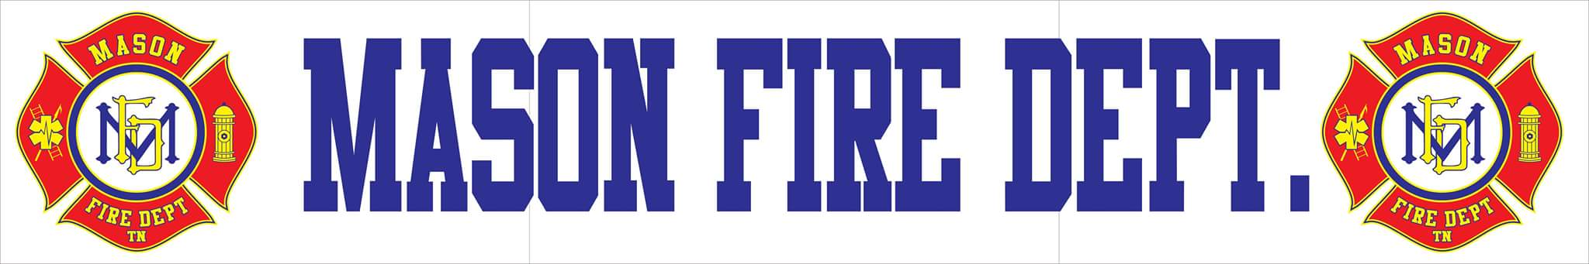
October 2020 COMMITTEE REPORT
- For the month of September, Mason Fire Department responded to a total of 17 incidents with a 100% response rate. Those incidents include:
    - 14 EMS Calls
    - 2 Motor Vehicle Accidents W/ Injuries
    - 1 Tree Fallen on Residence

- The department has officially received the three suction devices and four AEDs totaling
$5,930.00 from the Southwest Tennessee Electric Members Care Grant and are now in service on all apparatus.

- In order to help replace expired and worn out turnout gear, the department has applied for two separate grants from Southwest Tennessee Electric Cooperative and Firehouse Subs Grants.

- Currently, the department has a total of six personnel attending the Tipton County Recruit Class to challenge commissioned certifications for firefighter II and HAZMAT operations. One firefighter is currently challenging the EMT Basic certification through Dyersburg State Community College. All students are doing well and are expected to complete their courses in March of 2021.

- Through recent meetings with the Tennessee Firefighting Commission, Mason Fire Department has increased its training capabilities to certify fire/EMS personnel at a much faster rate through the use of certified in-house instructors allowing for access to increased levels of education. The department is now eligible to participate in the Tennessee Education Incentive for full-time fire personnel to receive up to $900 per firefighter who is commission certified for completing at least 40 hours of in-service training annually.

- At this time, all MAFD apparatus are full operational and responding to calls. Annual pump testing for Engine 72 and Tanker 74 will need to be completed prior to January 1st, 2021.

- The department is requesting for an open auction for the Chevy Blazer behind the station to be publicized for 30 days in the local newspaper with a starting bid of $750. This would be a sealed bid auction with the vehicle being sold as is.

