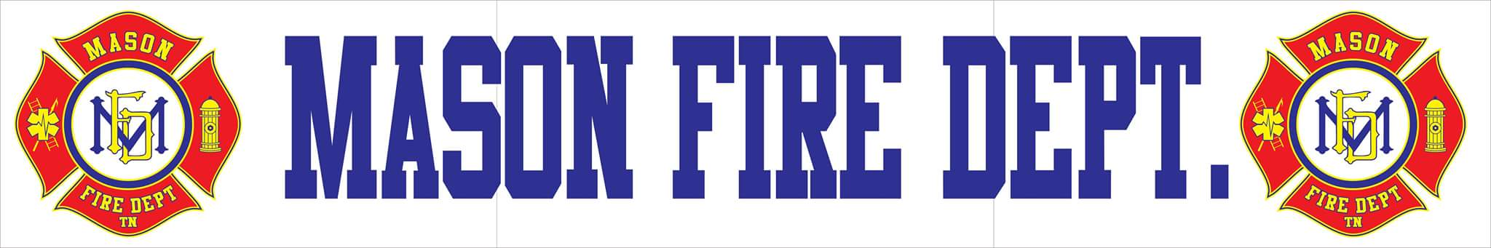
SEPTEMBER 2020 COMMITTEE REPORT
- For the month of August, Mason Fire Department responded to a total of 30 incidents with a 100% response rate. Those incidents include:
    - 23 EMS Calls
    - 1 Flood/Rescue
    - 1 Automatic Fire Alarm
    - 5 EMS Calls (Tipton County)

- At this time, the department is being limited on providing automatic/mutual aid for EMS out of district by Tipton County. Steps are being taken to resolve this issue.

- Upon receipt of the Pierce from repairs, all frontline apparatus are currently in service and responding to emergencies increasing the department’s flexibility.

- As part of the received Southwest Tennessee Electric Cooperative Grant, we have received the partial order of three suction devices ready to be placed in service immediately and are awaiting the four AEDs to arrive.

- The department has applied for an additional Firehouse Subs grant for eight sets of turnout gear and has applied for an additional Southwest grant for loose equipment and PPE.

- There are a number of fire personnel who will be attending various courses through the fall and early spring for certifications. One is currently attending Dyersburg State to achieve the certification of EMT-B and seven others are anticipated to attend the Tipton County Recruit Class to challenge Firefighter 2 commission certifications.

