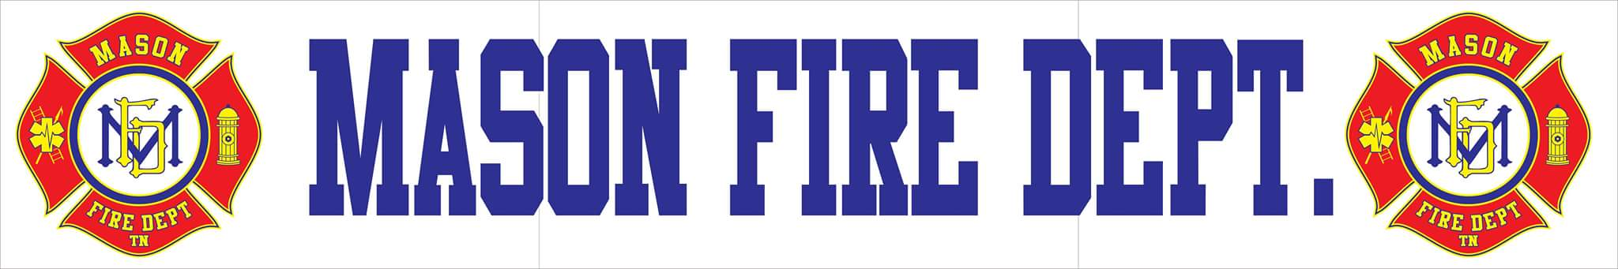
DECEMBER 2021 COMMITTEE REPORT

- Mason Fire Department responded to a total of 10 incidents for the month of November with a 100% response rate:
    - 4 EMS Calls
    - 1 Automatic Fire Alarm
    - 1 Automatic Fire Alarm (Tipton County)
    - 1 Motor Vehicle Accident W/ Injuries
    - 1 Motor Vehicle Accident W/ Injuries (Tipton County)
    - 1 Vehicle Fire
    - 1 Structure Fire (Fayette County)

- Engine 72 is still out of service and either needs immediate repairs to return to service or a replacement.

- The Tipton County Hazard Mitigation Plan has been approved and requires the board to adopt a resolution accepting the current plan.

- The fire hydrants for the Town of Mason located in both corporate limits and in Tipton County need maintenance and testing to meet AWWA and NFPA requirements. Rogers Hydrant Service has been the only third-party vendor to provide a service quote. Board approval is required to initiate the program. Hydrant testing and maintenance makes up a majority of ISO points effecting all fire department ratings who use the Town of Mason water system.

