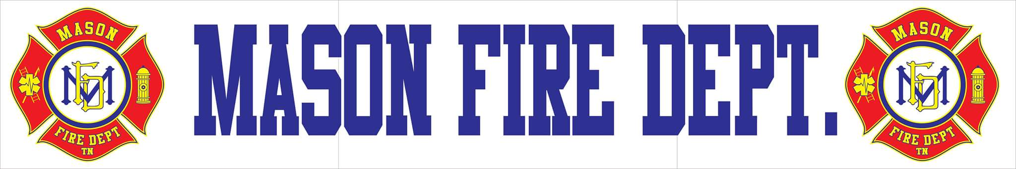
MAFD MARCH 2020 COMMITTEE REPORT
- For the month of February, Mason Fire Department had a 100% response rate and responded to a total of 18 incidents including:
  - 1 Motor Vehicle Accident-No Injuries
  - 1 Fire Alarm-False Alarm
  - 1 Structure Fire-Primary
  - 1 Structure Fire-Rekindle
  - 13 EMS Calls
  - 1 EMS Call-Tipton County
- At this time, the department’s roster consists of a total of 14 personnel. The department is currently seeking applications for volunteers to bolster the department’s numbers to meet the increasing demand for services by the community.
- As requested, Mason Fire Department is beginning the process of obtaining quotes from different manufacturers and vendors for the replacement of its turnouts. The current condition and quantity of the department’s personal protective equipment places firefighters at unnecessary risk for injuries and is a significant factor in preventing department growth to an appropriate level of personnel. The current state of turnouts can be demonstrated by the provided physical examples and attached photos. It is recommended that a purchasing committee be established in order to ensure a transparent process and further identify and meet the department’s needs for keeping its employees and citizens safe.
- Over the last few months, the department has been implementing strategies and improvements to further meet the needs laid out in order to satisfy ISO requirements and establish organizational growth moving forward. The department has developed a four-phase regrowth plan that will not only bring the Town into compliance limiting liability, but provide a path forward for community growth and greater public safety.
- As many know, the Federal and State governments have declared a state of emergency over the COVID-19 outbreak which will have impacts of the Town. At this time, no confirmed cases of Coronavirus have been confirmed in Tipton County. Preliminary cancellations of schools, colleges, and other institutions have already been self-implemented. There have been no official instructions provided at this time by Tipton County EMA or Health Department. Social distancing and good personal hygiene are being advised at this time with any functions with 50 people or more being recommended to cancel. More information will be provided when it is available on direct actions to take. It is recommended that the Town be prepared for a disruption of services as more actions are taken in the next few weeks.

Firefighter Turnout Gear Cancer Study
https://www.youtube.com/watch?v=UFzP1rQJWSQ

