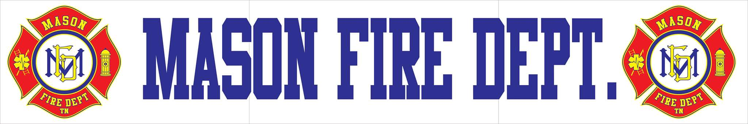
JANUARY 2021 COMMITTEE REPORT

- For the year 2020, Mason Fire Department responded to a total of 253 incidents with a 100% response rate.

- The department is now to provide automatic aid to Charleston and Three Star Volunteer Fire Departments for structure fires only.

- Earlier this month, the department was notified that it was selected by Southwest Tennessee Electric Cooperative to receive another grant opportunity for 4th quarter 2020 totaling $2,746.00 for some of the new fire hose for Truck 73.

- A newspaper ad has been placed in the Covington Leader requesting bids for fire hydrant service companies in the area. Rogers Hydrant Service is currently the only company to provide a quote for services to restore the Town’s fire hydrant system per AWWA, NFPA, and ISO standards.

- Three students have recently completed their live burn training and will be completing the commission course in the next month. Several other personnel will be challenging various certifications on January 30th.

- The station still does not have reliable internet and is beginning to hinder operations.

- A new vendor has been identified to provide the third quote for structural turnout gear and will be provided prior to the February meeting.

- It is recommended that the listing price for the department’s rescue truck be changed from $40,000 to $30,000 so attract more potential buyers.

