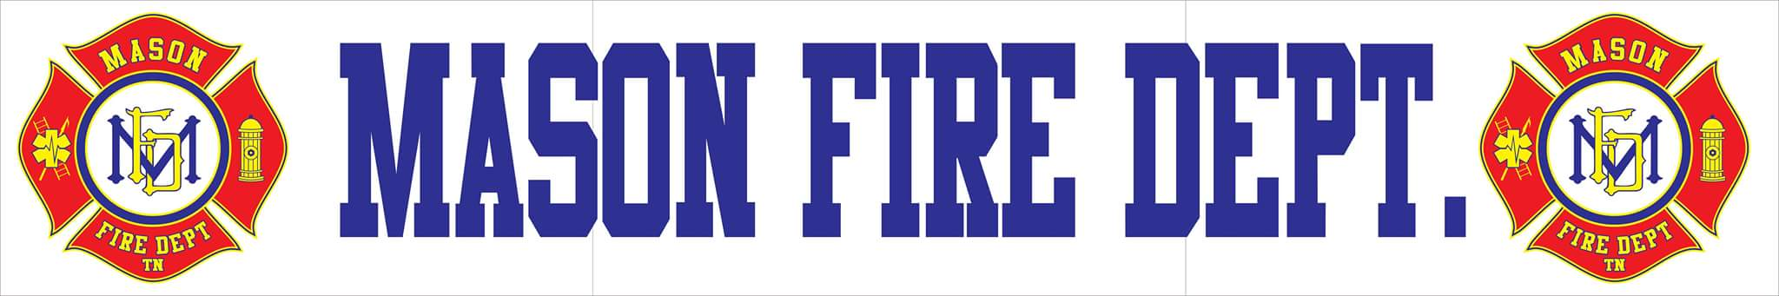
JULY 2020 COMMITTEE REPORT
- For the month of June, Mason Fire Department responded to a total of 28 incidents with a 100% response rate. Those incidents include:
      - 24 EMS Calls
      - 2 EMS Calls-Tipton County
      - 2 Automatic Fire Alarm

- The department has completed a shift in policy requiring volunteer personnel to complete a minimum of 12 hours of staffing per month and 12 hours of department hosted training to increase available personnel and further meet ISO training requirements for effected personnel.

- In the last month, one firefighter has completed the Tipton County School of Firemanship for over 300 hours of training for commission HAZMAT and Firefighter 1 & 2 national certifications. Graduation will be on July 22nd, 2020. Four other fire personnel received state required intro certifications qualifying them to begin responding under supervision to emergencies and one firefighter has completed certification testing for the Advanced Emergency Medical Technician (AEMT) certification.

- At this time, there is now working air conditioning at the fire department. Firefighters have begun staffing in the evening hours due to high heat conditions for safety concerns. The department is currently seeking quotes to replace an existing AC/heat unit inside the office.

- Final pricing has continued with a third vendor completing a quote for structural turnout gear maintaining the $60,000 spending limit. Quotes have been received by Safe Industries, Emergency Vehicle Specialists, and Municipal Emergency Services for Globe and Fire Dex brand turnouts. Each quote is generated with minimum 5-year financing options in order to maintain an affordable balance in general fund budgeting. Due to the cost in replacing the department’s current PPE, it is recommended that the town advertise open bidding for a set amount of time to allow opportunities for other vendors to provide pricing.

- The department’s engine 2 is still undergoing repairs at G&W Diesel in Memphis and is near completion. Expected final costs of labor are unknown at this time and an estimated $3,500 in parts were replaced. Once completed, the engine will be fully prepared to enter service as a first due engine allowing the Mason Fire District to be protected so the department’s other apparatus can be tested annually per NFPA and ISO standards.

- The F350 rescue truck has been listed on Brindlee Mountain Fire Apparatus for the price of $40,000 per the board’s request and is now available for purchase. If purchased, the town will be responsible for a 10% sellers fee to Brindlee Mountain for advertising and sale returning $36,000 to the town compensating for the potential purchase of the desired ladder truck. The department has also revived an existing GovDeals account in order to list the vehicle and others approved for sale by the board in online auction.

- Through approval by the board, the department has continued in efforts to purchase the 1996 Saulsbury Simon-Duplex 55’ Telesquirt as the town’s first ladder truck from Syracuse, New York. The department was able to obtain a quote for a loan through Community Leasing Partners for the whole expected total of the purchasing project for $35,000. The approved quote has either a $7,000 or $5,000 down payment option financing a total of $30,000 on a fixed interest rate on a 3-year financing plan. There are no further fees associated with an completed agreement. With the anticipated sale of the rescue truck to return a value of $36,000 , the approval of the loan would allow the immediate purchase of the ladder truck and complete funding of transport and annual required testing with the current owner’s testing vendors ensuring that it will be ready to respond immediately once arrived.

- At this time, all fire hydrants located in the Town of Mason’s municipal limits and county areas need of flow testing, flushing, painting, and mapping to ensure compliance with NFPA and AWWA standards. This compliance is also 40% worth the Town’s overall ISO scoring for its Public Protection Classification affecting insurance rates. Roger’s Hydrant Service located in Atwood, Tennessee (the same vendor who services the City of Covington’s hydrant system) has provided a pricing of a complete revamp of the Town’s hydrant system as part of a required three year contract for a total of $65.66 per hydrant per year cost for flush/flow testing with mapping and $75.00 per hydrant to be correctly painted to NFPA and AWWA standards identifying flow capacities for fire department operations. It would be the department’s recommendation to consider this as an alternative service to return to compliance. A representative would be available to answer any questions that the Town will have.

